

50.035 Computer Vision Project Report

On Plant Seedlings Classification Problem - Kaggle Competition

**Table of Contents**

**Background** **3**

Motivation 3

Dataset 3

**Approach** **3**

Exploring the Dataset & Preprocessing 4

Noisy Images 4

Unbalanced Dataset 5

Image Preprocessing and Augmentation 6

Image Masking to Remove Background and T-SNE 6

Data Augmentation 8

**System Design** **9**

The Models 9

3 Different Models 9

2 Data Augmentation Functions 9

Experiment Results 10

Model 1 10

Basic Data Augmentation 10

Robust Data Augmentation 11

Model 2 12

Basic Data Augmentation 12

Robust Data Augmentation 13

Model 3 14

Basic Data Augmentation 15

Robust Data Augmentation 15

Conclusion 16

Summary 17

Insights 17

**Future Work** **18**

**Workload & Contribution** **18**

# Background

## Motivation

In agriculture, weeds compete for sunlight and nutrients in the soil, which can lead to stunted growth of other plants. Identifying and removing these weeds can be a tedious and time-consuming process for farmers. As such, an image classification solution that can effectively differentiate plants from weeds could potentially ease the farmers’ job and improve crop yields. Such a solution can also be integrated with automated robotic farming: developing a robot to automatically detect and remove weeds.

## Dataset

The dataset used in this project is released by the Aarhus University Signal Processing group, in collaboration with University of Southern Denmark and consists of images of approximately 960 unique plants belonging to 12 species at several growth stages.

## Problem

Based on the plant seedling dataset we are given, we need to classify the images into one of 12 classes. Some seedlings greatly resemble each other, for example, Black grass and Loose Silky Bent, so we would need to experiment to discover which models work best. We would like to extend our model’s application to photos of plant seedlings taken in reality which would have more skewed perspectives and possibly only catch part of the plant, to discover how our model will do on those pictures, we tested our models on a data augmented dataset too.

# Approach

We first visualized the data so we could see what our model would need to learn. We found that images has a variety of different backgrounds that would introduce noise into our model and that the dataset was unbalanced.

In order to remove noise, we used image masking to remove the background by selecting only for a certain range of green hue and removing other colors. Our team also eased the unbalanced dataset using a data generator to increase the number of images within the dataset, this data generator also made the model more robust by giving it a wider variety of images of seedlings.

## Exploring the Dataset & Preprocessing

### Noisy Images

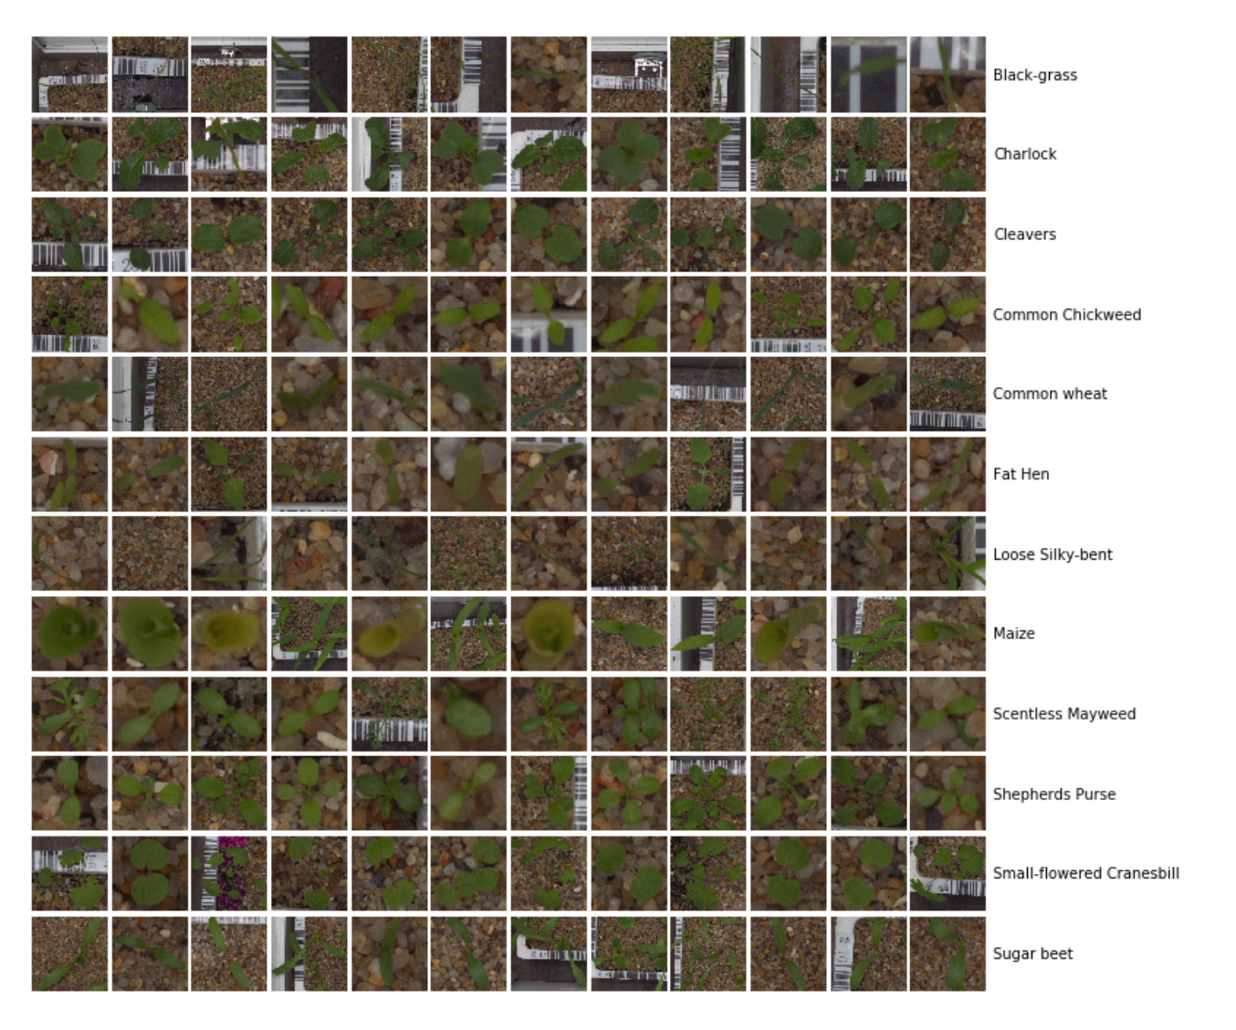

We visualized the photos of the different plant seedlings from each classification as shown above and found that the background of the images were varied as can be seen from the bar codes and soil in the background of the sample pictures above. This would introduce noise into our model. This problem will be addressed in the Image Pre-processing section of our report.

### Unbalanced Dataset

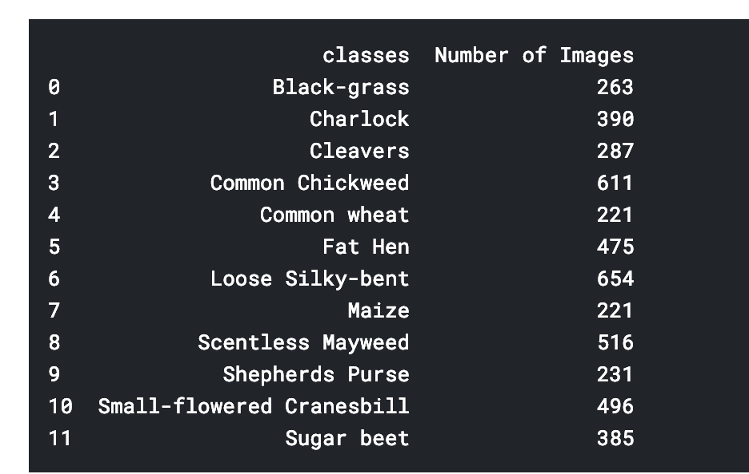

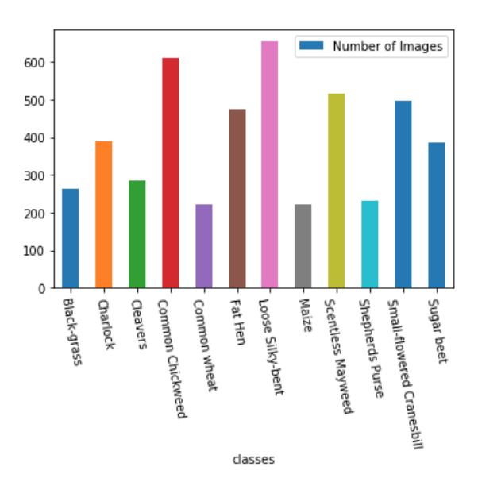

We visualized the number of images available for each class and found that the dataset is unbalanced, which we have to take into account when training the dataset. This will be addressed in the Data Augmentation section of the report.

## 

## Image Preprocessing and Augmentation

### Image Masking to Remove Background and T-SNE

We decided to use image masking to remove the background so that the model is only looking at the shape of the seedlings as shown by the pictures below.

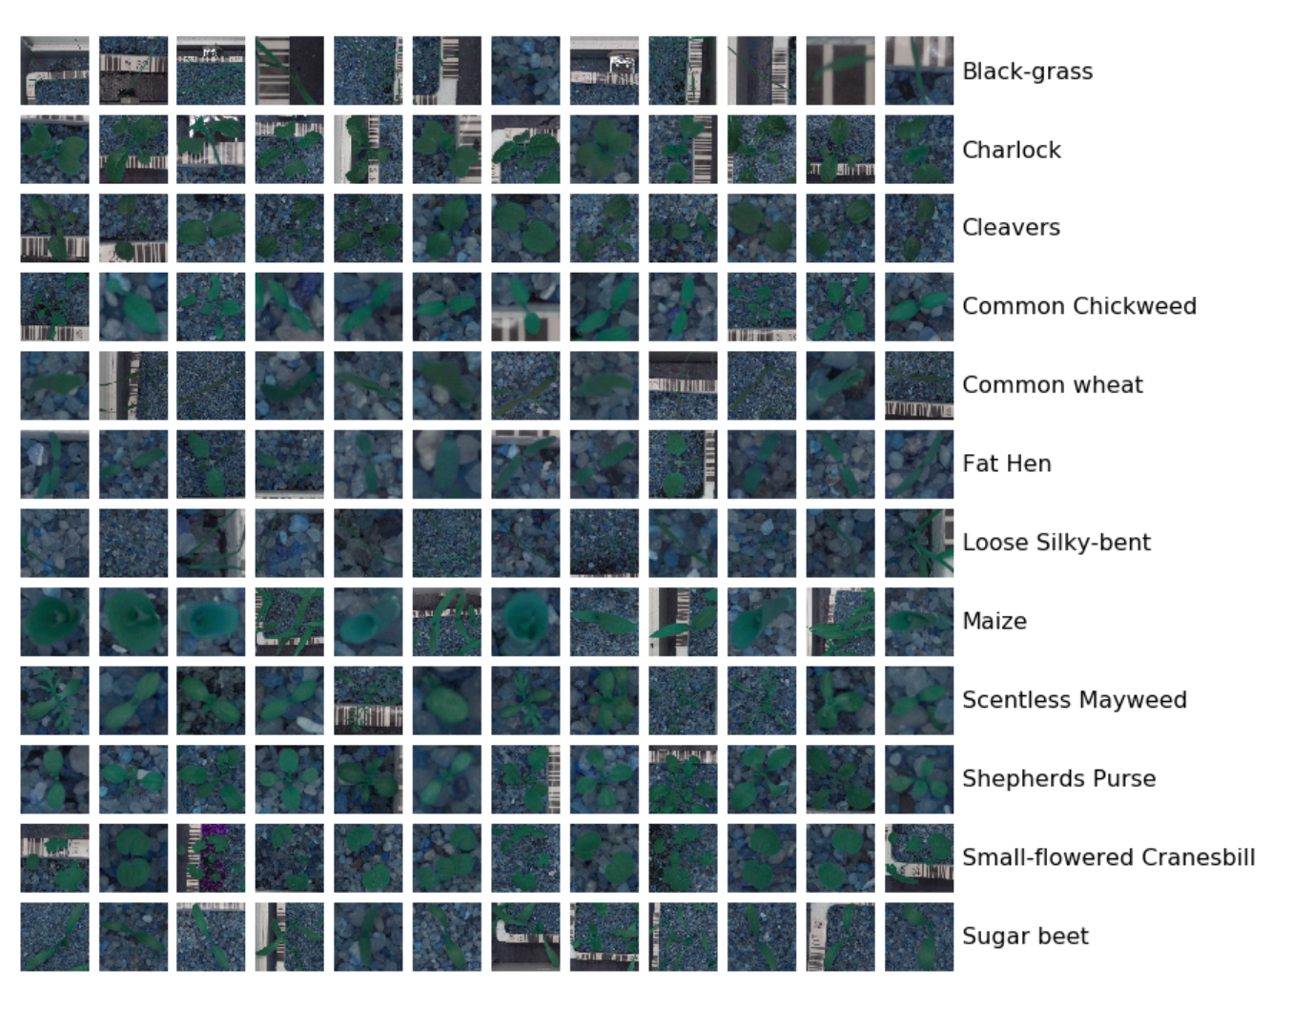Before Masking

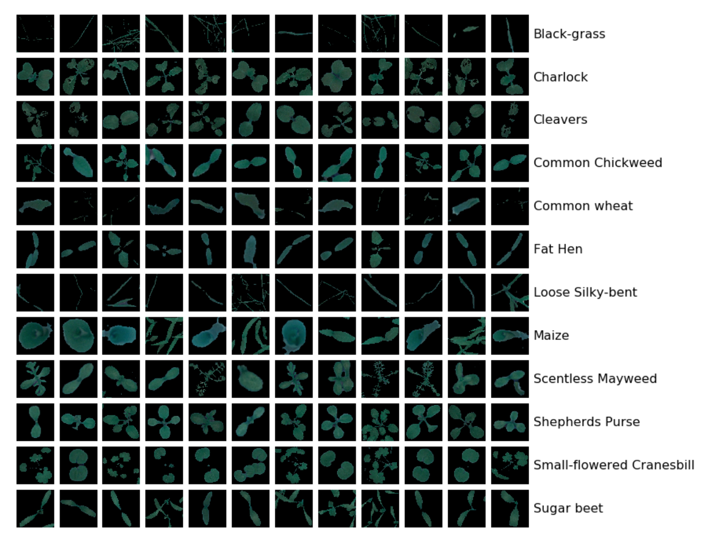After Masking

We used the following code to go through each training image to remove the background of the image. First we used a gaussian blur to remove noise, then we converted to a HSV image and used a boolean mask to remove colors that were not in our green color range.

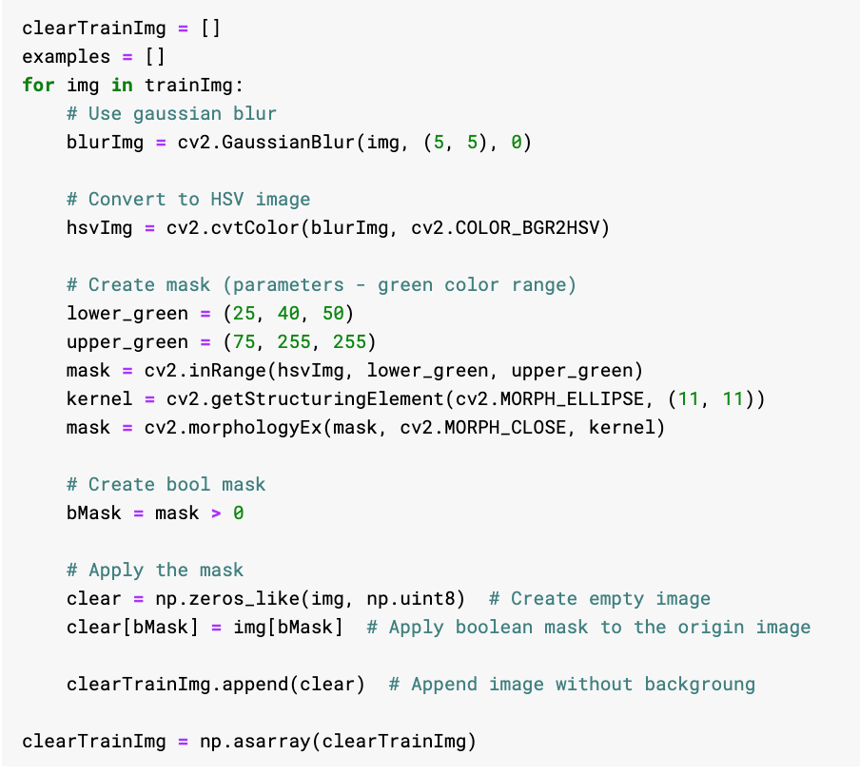

We obtained the T-SNE below from the original dataset with the original images.

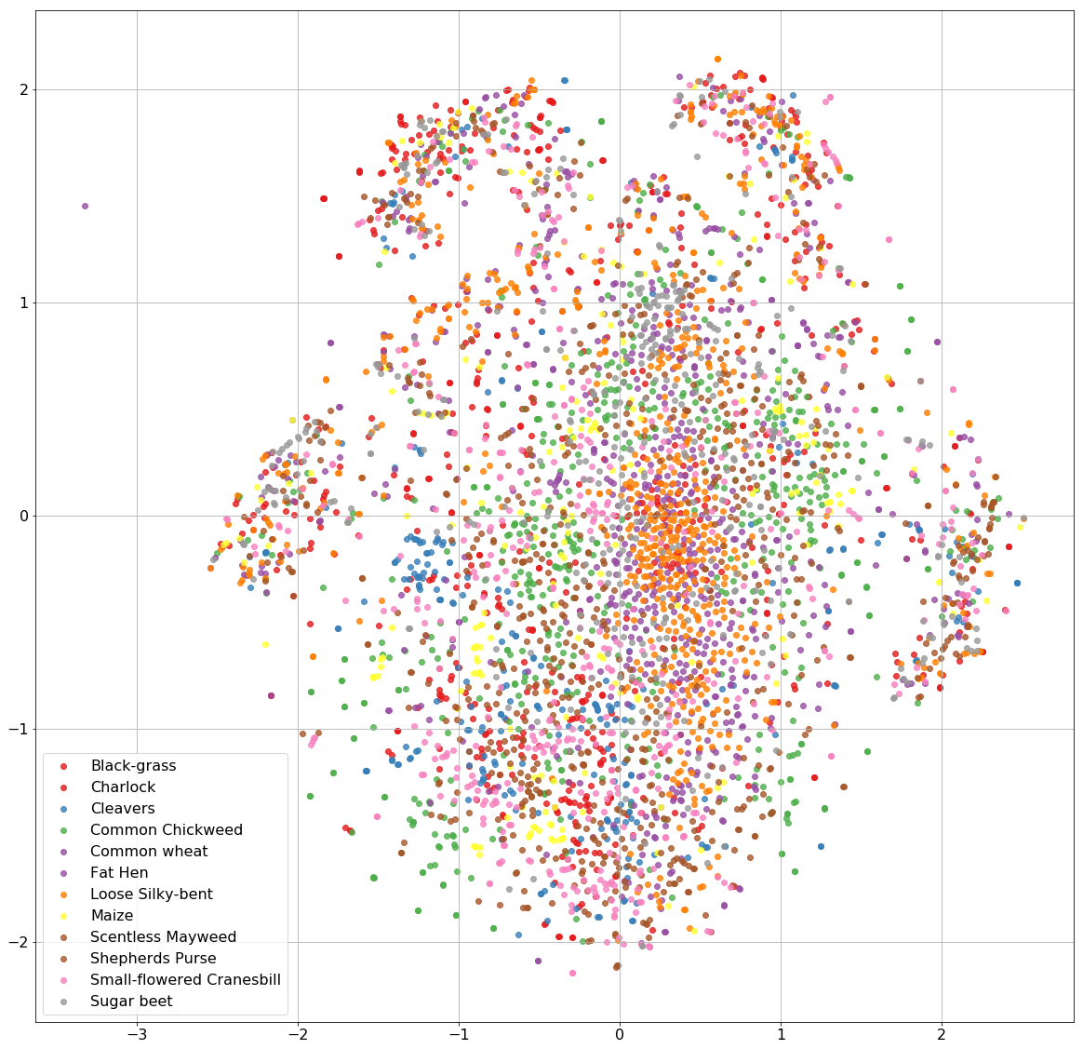

We obtained the T-SNE below from the modified dataset with the masked images.

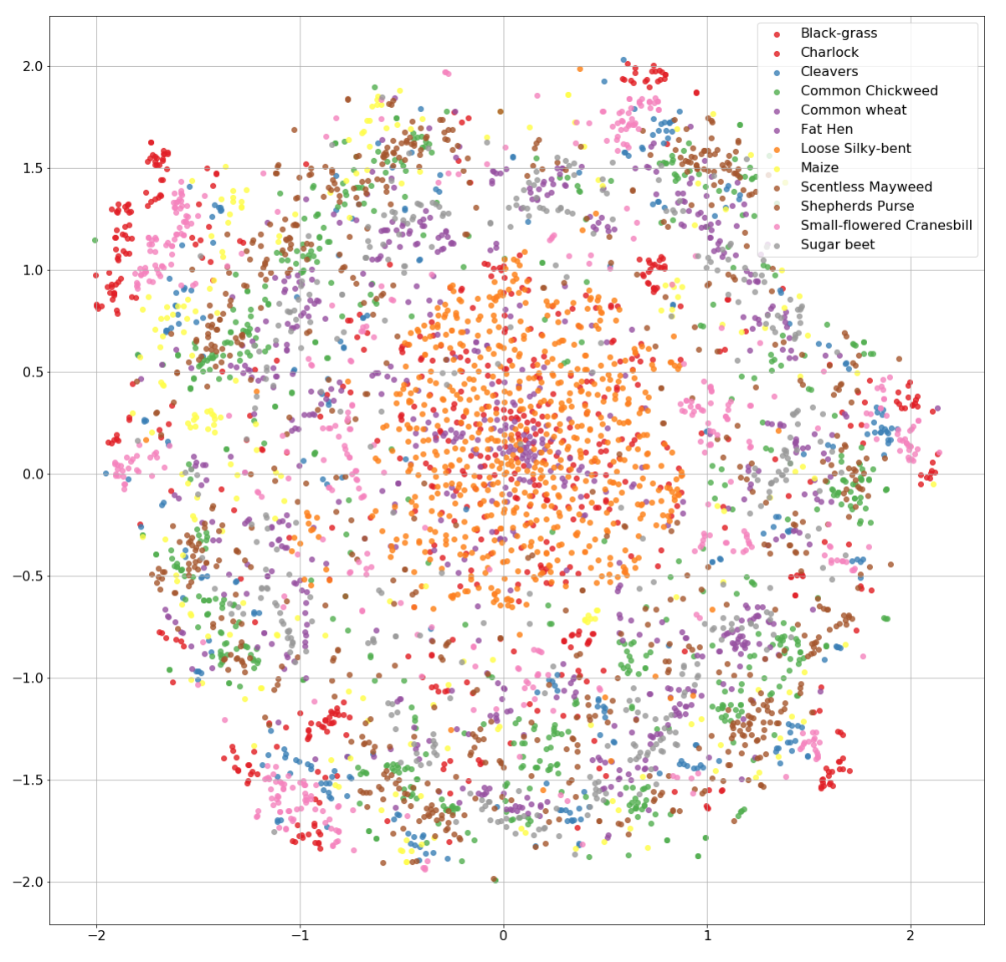

We obtained the T-SNE below from the modified dataset with the masked images, this variant shows the photos of the masked images plotted on the T-SNE graph.

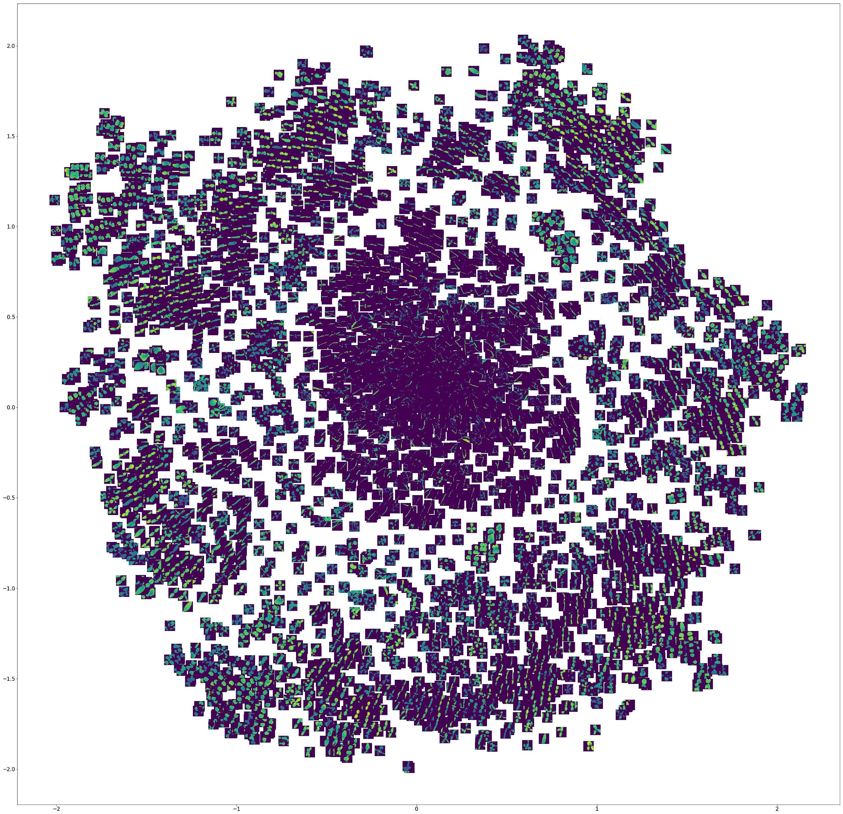

As can be seen by comparing the T-SNE from the modified dataset with the T-SNE from the original dataset, image masking allows enables better differentiation between the different classes.

## Data Augmentation

In order to deal with the unbalanced dataset, we will generate more images for the dataset as it will ease the imbalance while allowing us to take full advantage of the limited images in this dataset. This approach was based off how the google paper on detecting diabetic retinopathy achieved high accuracy in a dataset where positive cases were between 10% and 30%.[1]

We will also randomly performing rotation, zoom, horizontal shift and vertical shift on the images so that our model will be robust - able to generalize and classify images under different illumination conditions, viewpoints and with only parts of the plant seedlings shown.

This is our basic data augmentation function:

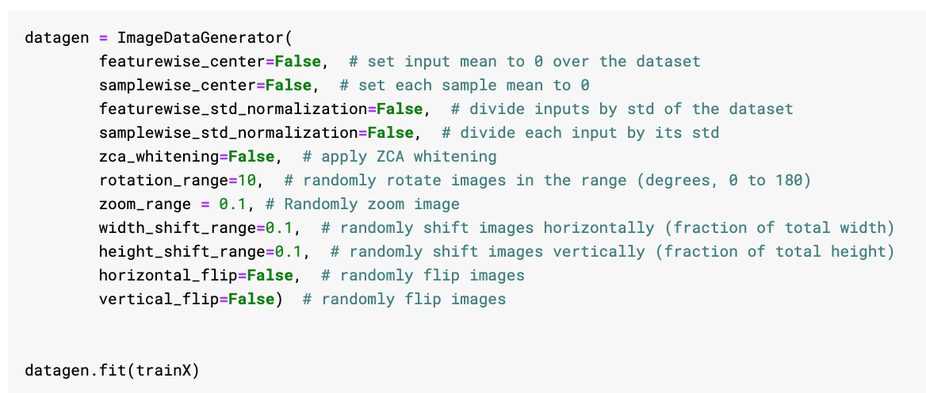

This is our robust data augmentation function which has a much greater rotation range and uses horizontal flip and vertical flip to vary our dataset to greater mimic real life conditions.

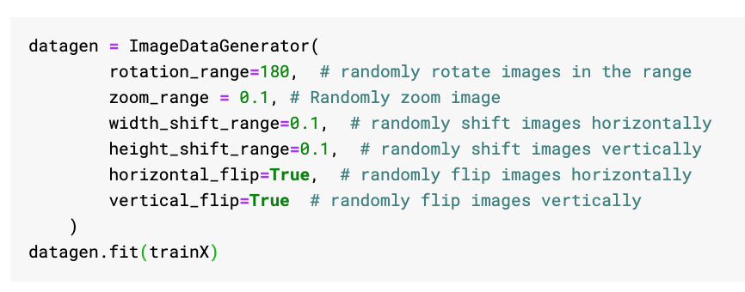

# System Design

## The Models

### 3 Different Models

We tried 3 different models. For each model, we evaluated it based on the results obtained from training the model for 50 minutes on Kaggle with a GPU enabled. We tried running each model with a basic data augmentation function and a more robust data augmentation function.

#### Key Methodology

##### Dropout

All of our models made use of the Dropout regularization technique for neural network models to prevent overfitting. In this technique, randomly selected neurons are ignored during training. The use of dropout ensures that the network becomes less sensitive to the specific weight of neurons which results in a network that is capable of better generalization and less prone to overfitting data.

##### Learning Rate Reduction on Plateau

Our model trains using the callback, ReduceLROnPlateau to monitor the validation accuracy and upon 3 epochs without improvement, the learning rate will be reduced as models tend to benefit from reducing the learning rate once learning stagnates.

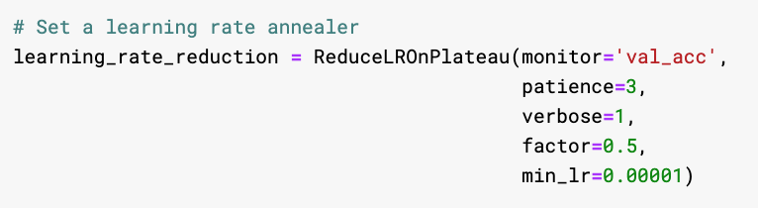

##### Optimizers

Model 1 and Model 2 uses the Adam optimizer while Model 3 uses the The Root Mean Square Propagation (RMSprop) optimizer.

###### Adam Optimizer

The Adam optimizer is said to combine the advantages of two other extensions of stochastic gradient descent, Adaptive Gradient Algorithm and RMSprop. Adam is a popular algorithm in the field of deep learning because it achieves good results quickly and was recommended in this paper[2].

###### RMSprop Optimizer

The Root Mean Square Propagation (RMSprop) optimizer automatically adjusts the learning rate for each parameter. The per-parameter learning rates are adapted based on the average of recent magnitudes of the gradients for the weight. This means the algorithm does well on online and non-stationary problems. It implicitly performs simulated annealing because RMSProp automatically will decrease the size of the gradient steps towards minima when the steps are too large to prevent overshooting.

###### Comparison

It is said that Adam slightly outperforms RMSprop towards the end of optimization when the gradients become sparser because of its bias correction. However, in the Keras documentation, RMSProp optimizer is recommended for recurrent neural networks. People have also found that Adam does not get the test set performance RMSProp gets on Image CNNs as it is more prone to overfitting.

Generally the optimizer performance depends on the tuning of the optimizer’s parameters so we simply tried out standard parameters used by others for the same dataset in our models.

### 2 Data Augmentation Functions

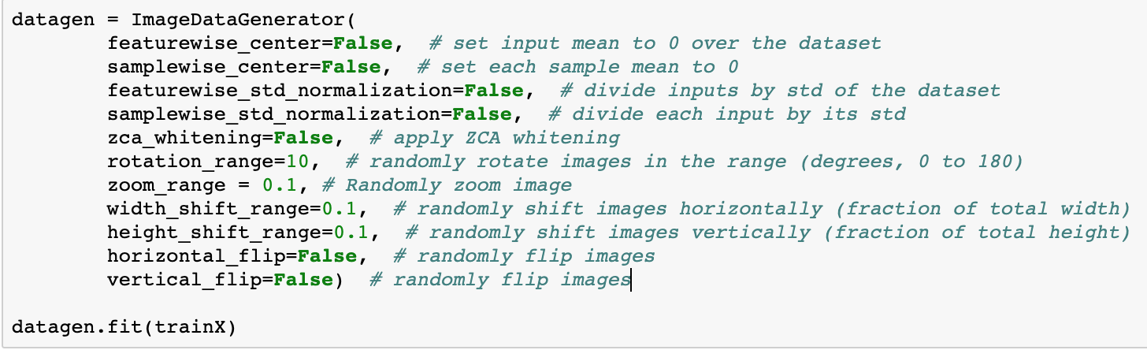

The basic data augmentation involves slight shifts to the image as shown above. We experimented with the features above and set the ones which were detrimental to the overall testing accuracy of the dataset to false.

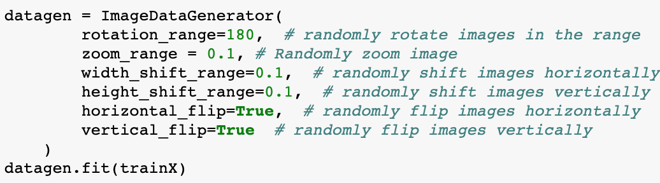

The robust data augmentation would ideally make the model more robust against photos with different perspectives and pictures where only part of the seedling could be shown.

The basic data augmentation function is sufficient for the competition. The robust data augmentation was an extension of our project to see how the models could adapt to photos of seedlings in reality.

## Experiment Results

### Model 1

This model is a basic deep learning model, based off the idea that initial layers are only learning primitive layers and hence filter size should increase for later layers for the convolution portion as they are learning high level features. The Fully Connected Net at the end have 3 hidden layers because it was said that for fully connected neural nets, 3 layers have been proven to perform better than 2 layers but beyond 3 layers, it depends on the dataset.

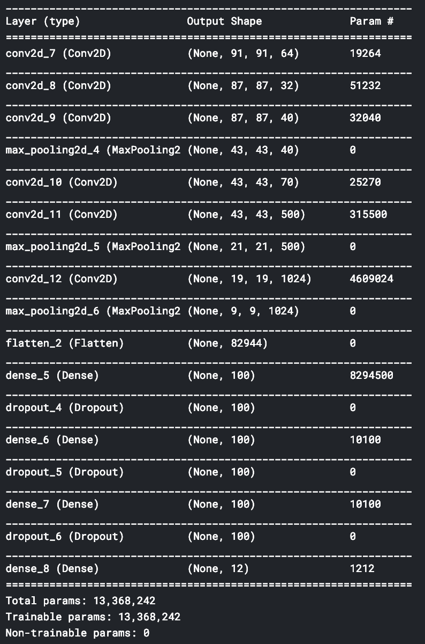

#### Basic Data Augmentation

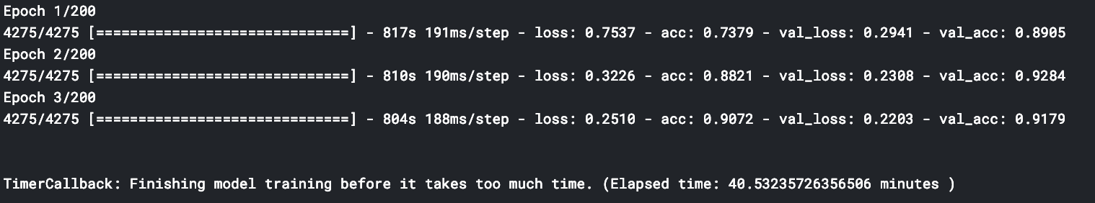

We ran the model for 3 epoches and achieved a 90.2% accuracy on the test set and a 91.7% accuracy on the validation set after 40 minutes as shown above. This indicates that our model is not overfitted and considering that the accuracy was improving with each epoch, the model might benefit from running for more epoches.

#### Robust Data Augmentation

We ran the model for 30 epoches and achieved a 81.02% accuracy on the training set and a 82.1% accuracy on the validation set after 50 minutes as shown below. This indicates that our model is not overfitted and might benefit from running for more epoches.



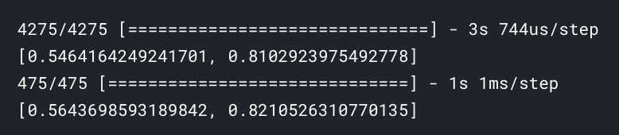

The confusion matrix below shows how this model does for each category.

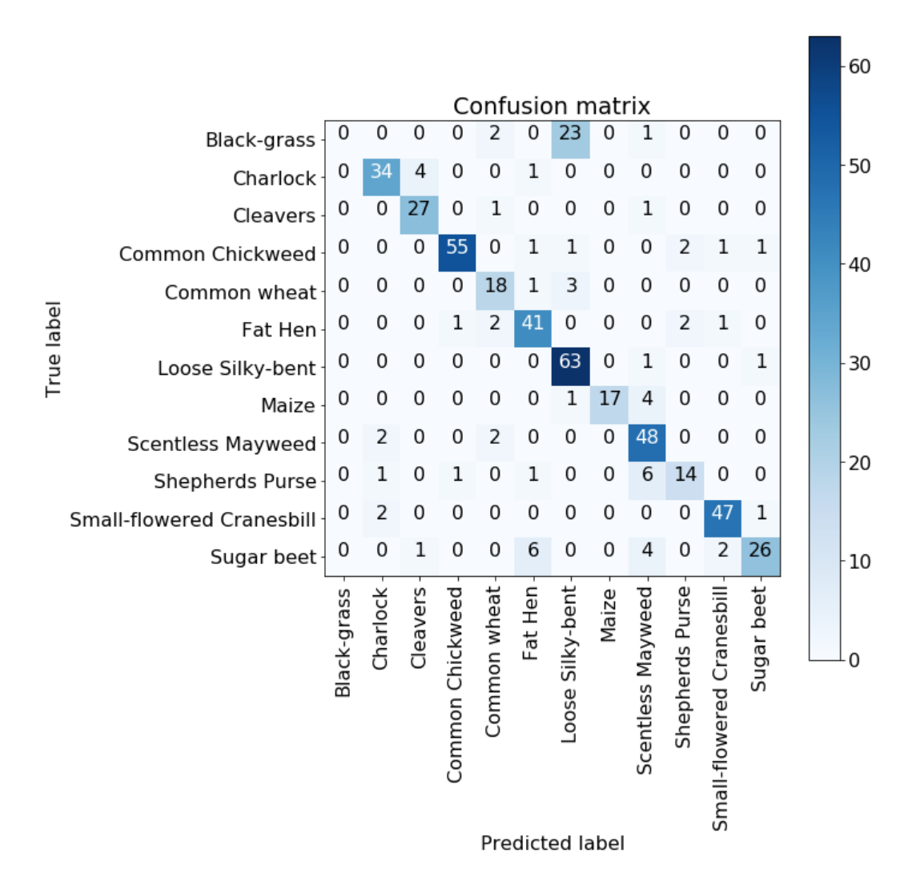

### Model 2

This model is based off the idea that max pooling layers can be replaced by convolution layers with a larger stride[3], because there are too many parameters, I reduced the number of filters which should decrease the performance of the network.

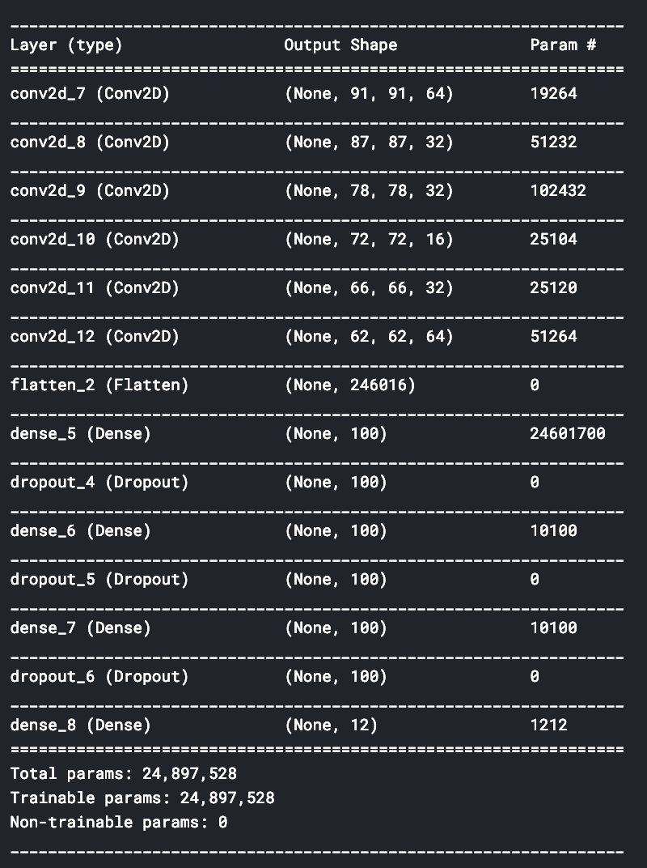

#### Basic Data Augmentation

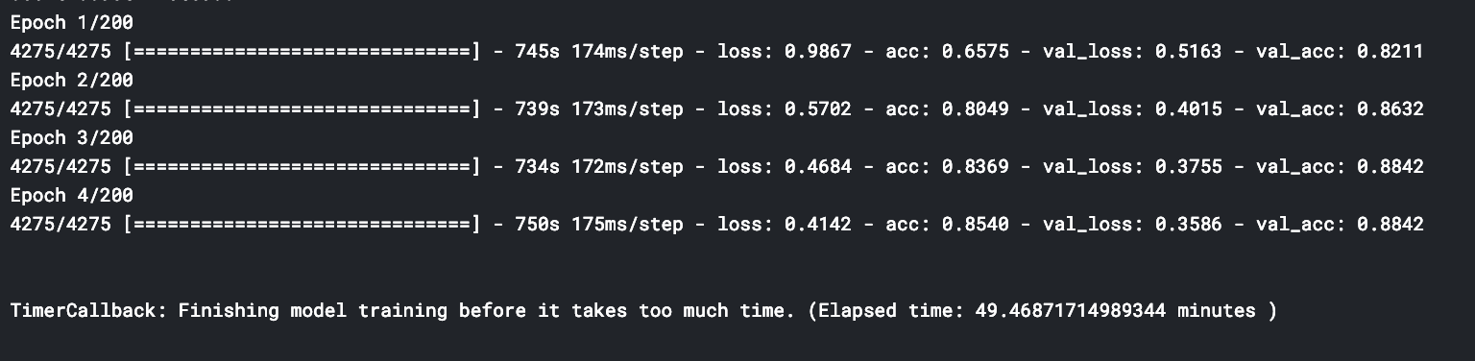

We ran the model for 4 epoches and achieved a 85.4% accuracy on the training set and a 88.4% accuracy on the validation set after 40 minutes as shown above. This indicates that our model is not overfitted and considering that the accuracy was improving with each epoch, the model might benefit from running for more epoches.

#### Robust Data Augmentation

It ran for 30 epoches but achieved a 13.7% accuracy on the test set and a 13.6% accuracy on the validation set after 50 minutes as shown below. This accuracy is slightly better than random guessing but serves to show that models with more parameters are not necessarily more accurate.



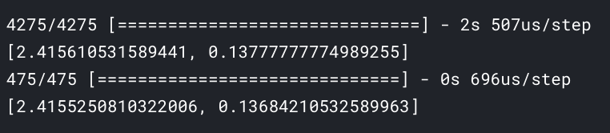

However when we look at the confusion matrix, we see that the model was simply predicting the classes for all the images to be loose silky-bent which essentially means the model wasn’t really accurate at all.

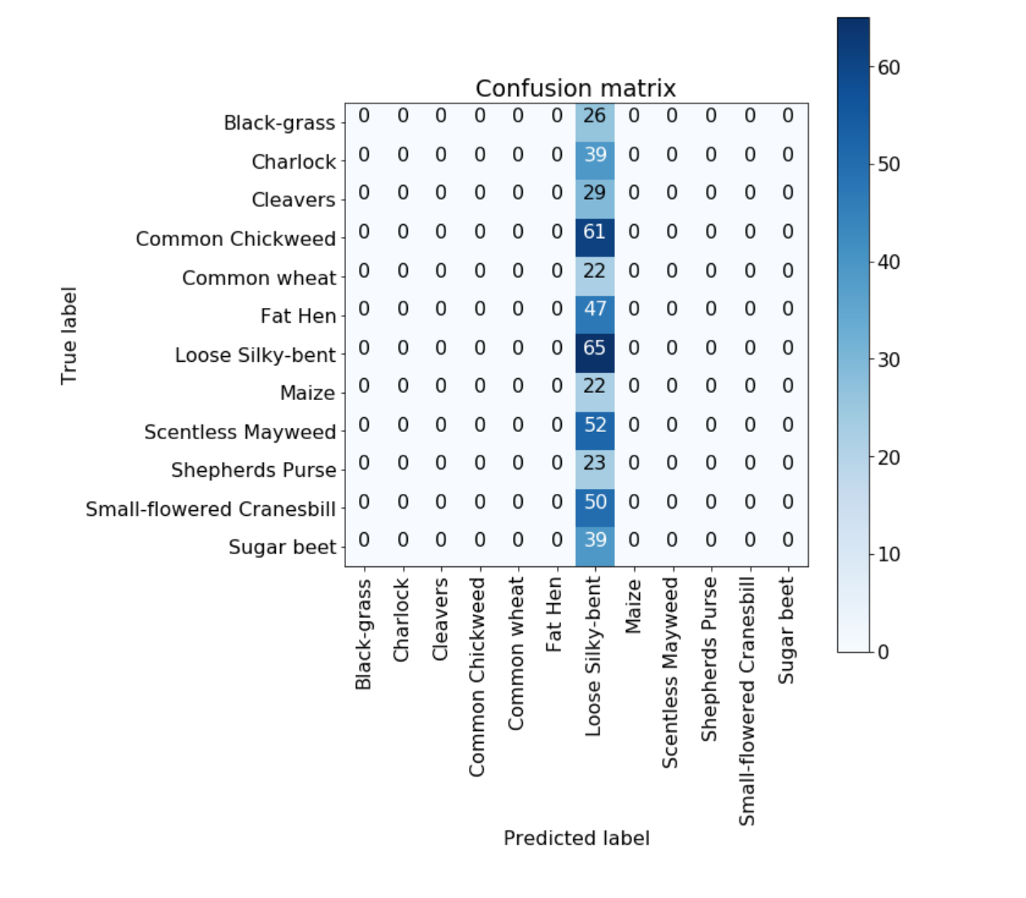

### Model 3

This model is simpler than both other models tried, it was inspired by a Kernel on a Digit Recognizer dataset[4] which was a 5 layers Sequential Convolutional Neural Network that uses a different optimizer from our previous models.

#### 5 Layer Sequential Convolutional Neural Network

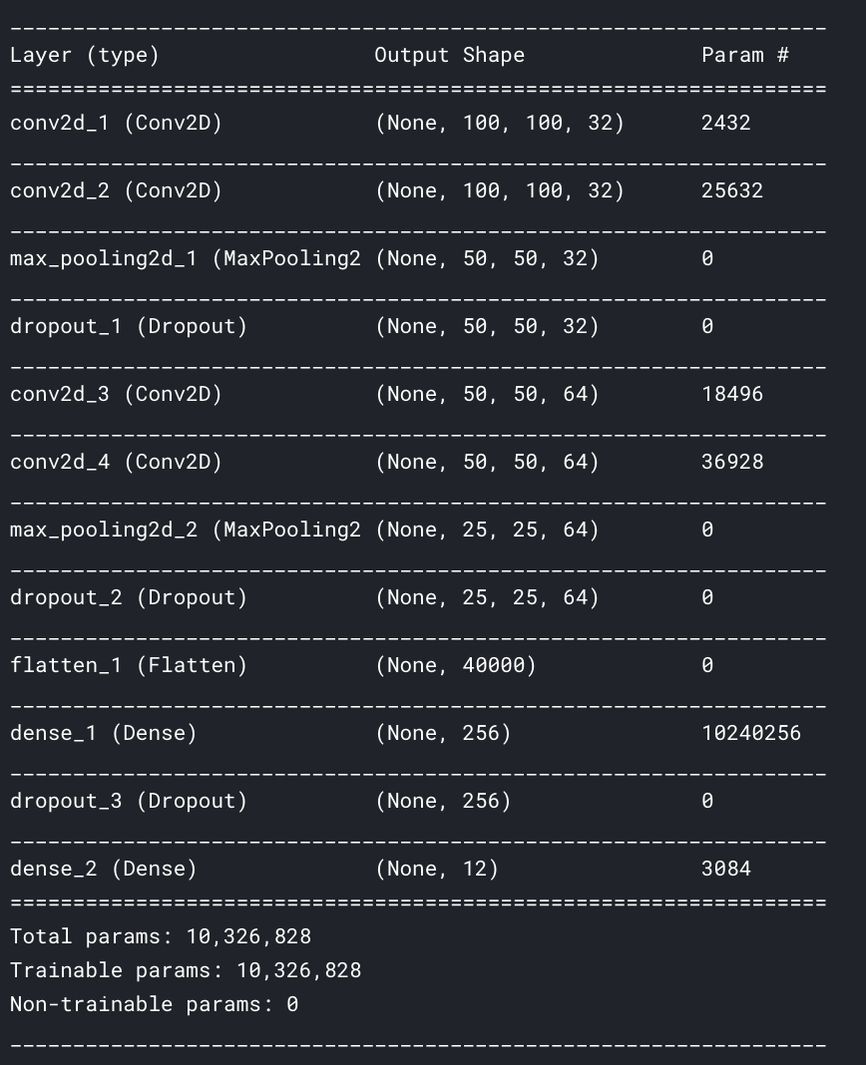

We first tried running this model on our dataset which gave us the following results:

##### Basic Data Augmentation

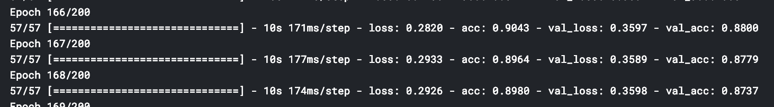

We ran the model for 168 epoches at which point the model was starting to decrease in accuracy for both the training set and the validation set. At epoch 166, It achieved a 90.4% accuracy on the training set and a 88% accuracy on the validation set after 50 minutes as shown above. This indicates that our model is couldn’t really improve further through training (saturation).

##### Robust Data Augmentation

After 80 epoches, the model reached the point where it’s accuracy was sometimes decreasing with each epoch. It achieved a 89.4% accuracy on the test set and a 88.6% accuracy on the validation set after 50 minutes as shown below. This indicates that our model might be overfitted and won’t really benefit from running for more epoches.



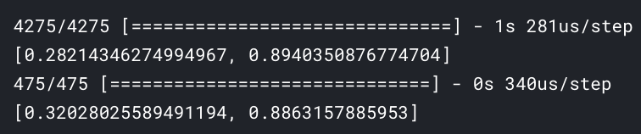

The confusion matrix below shows that similarly to model 1, this model also doesn’t do well for the black-grass class label.

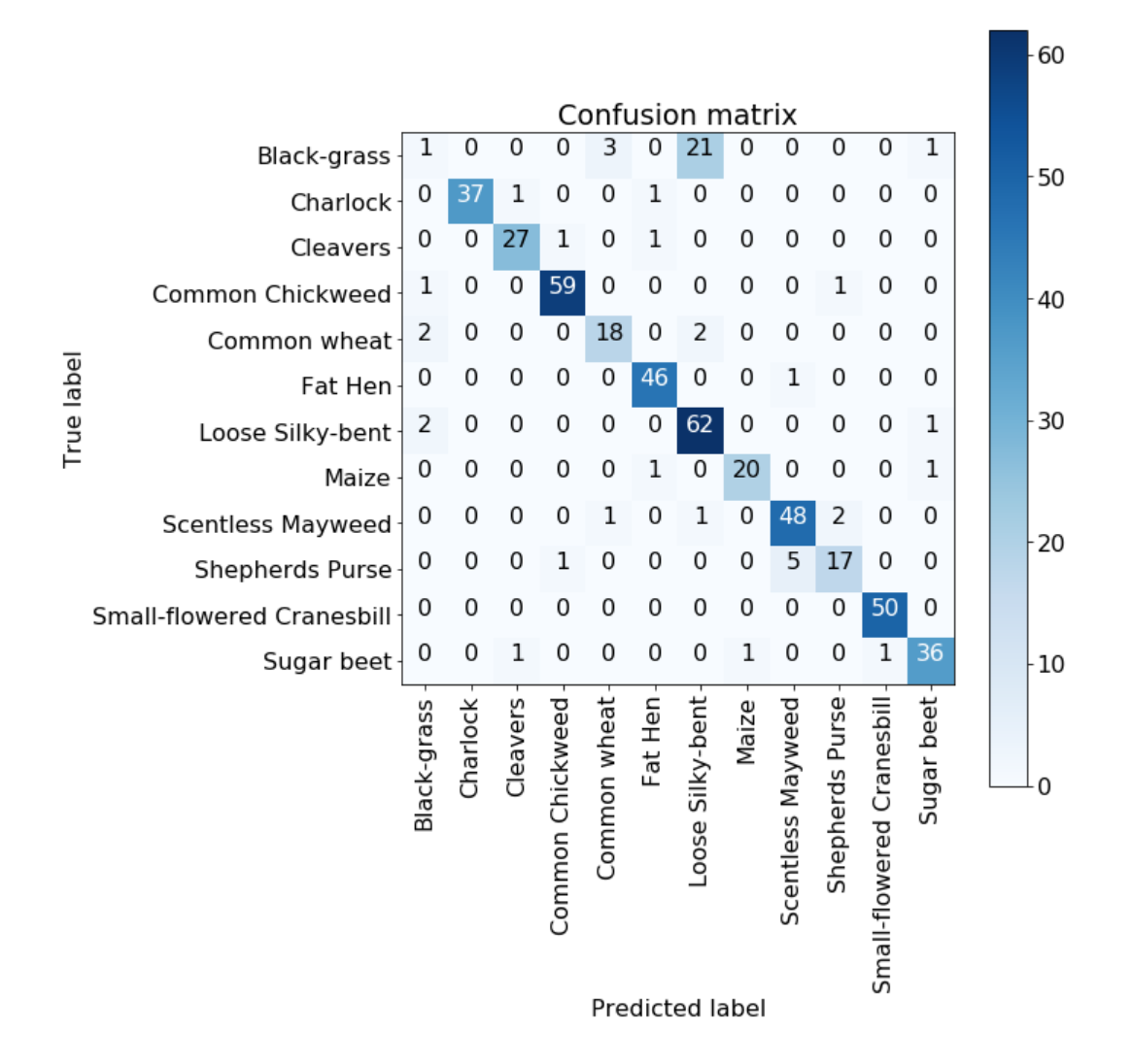

#### Our Modified Model

Our implementation has an added dense layer and different parameters for filter sizes and dropout rates.

We changed to the same optimizer as shown below.

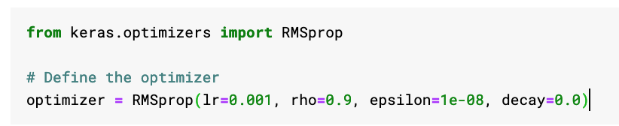

The key idea behind this model is that running for more epochs is likely to lead to a more accurate model than having more parameters so the number of filters was decreased greatly although we kept with the idea that the deeper layers should have more filters.

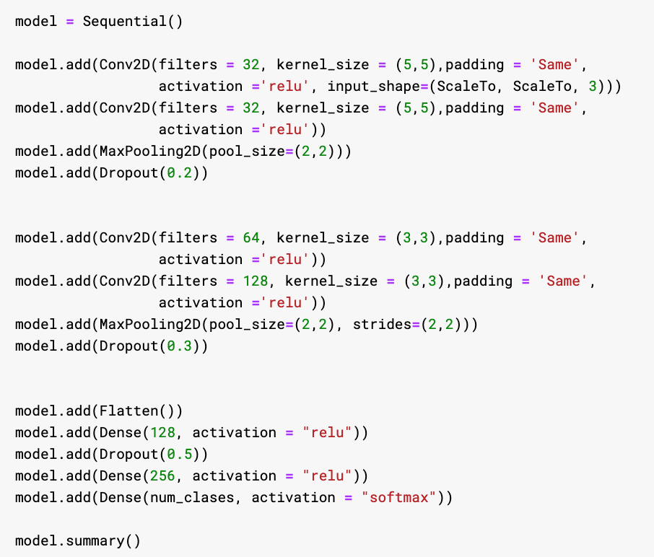

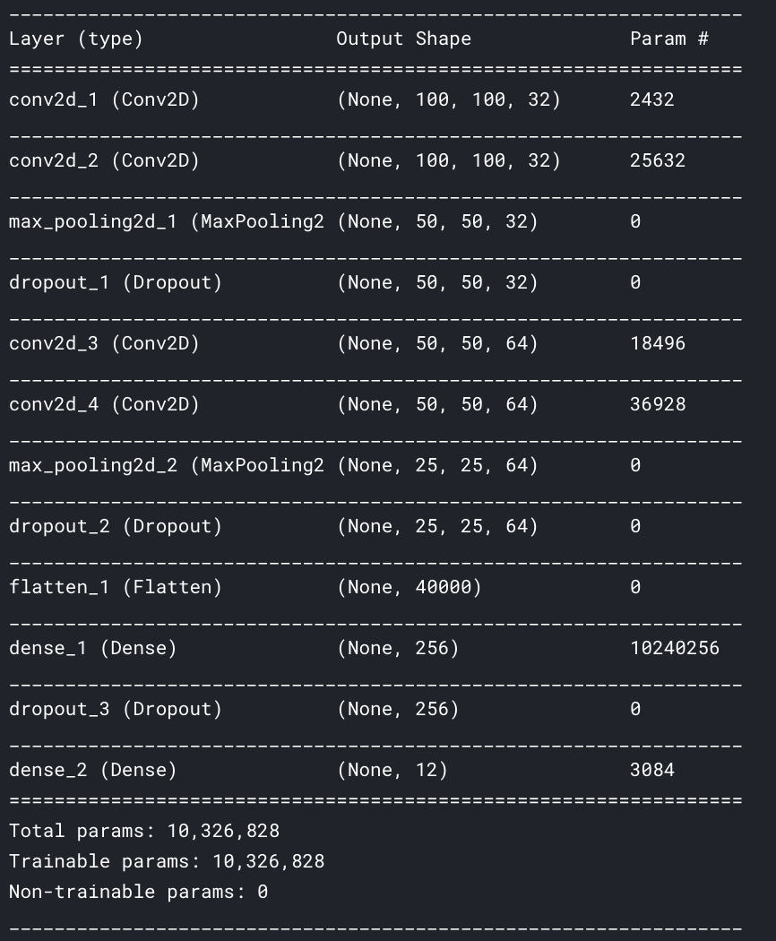

#### Basic Data Augmentation

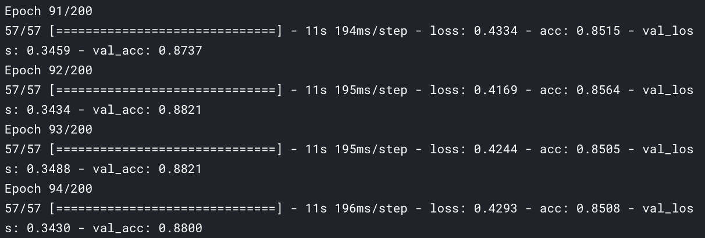

We found that the validation accuracy peaked at epoch 93.

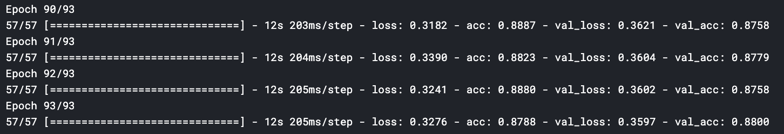 We ran the dataset again. It achieved a 87.88% accuracy on the training set and a 88.00% accuracy on the validation set as shown above.

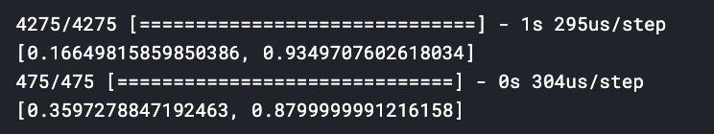

We evaluated it and found it to have a 93.49% accuracy on the training set and 87.99% accuracy on the test set.

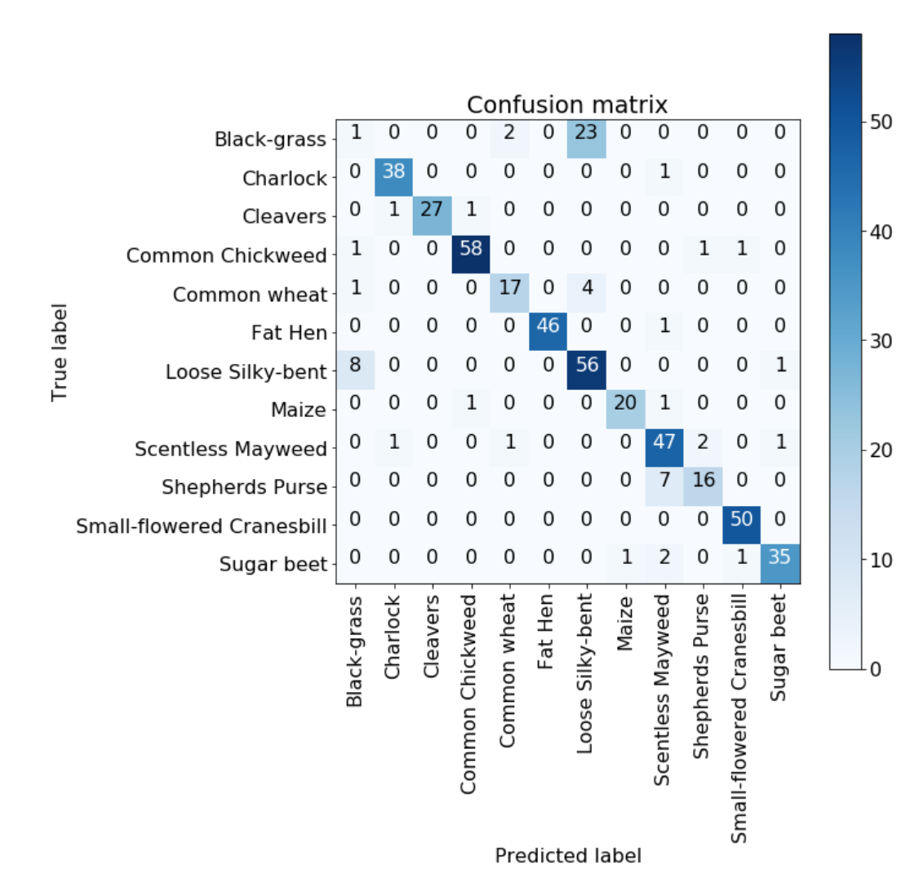

The confusion matrix above shows that similarly to model 1, this model also doesn’t do well for the black-grass class label.

#### Robust Data Augmentation

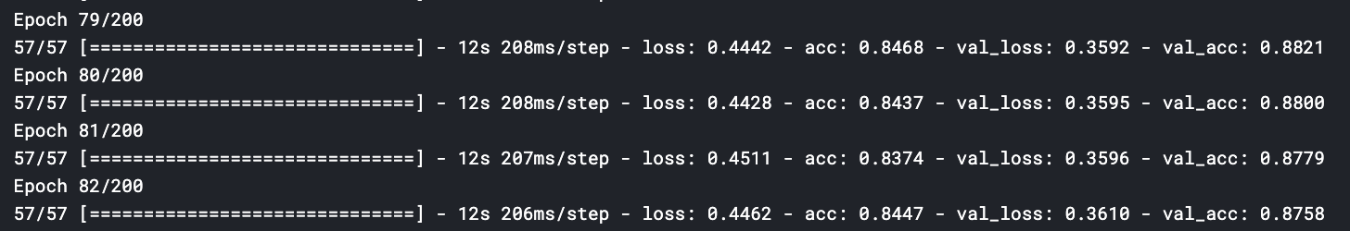

We found that the model peaked in validation accuracy at Epoch 79 at which point it started to decrease.

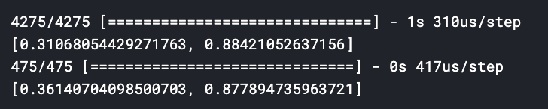

The model achieved a 88.4% accuracy on the test set and a 87.7% accuracy on the validation set after 50 minutes as shown below. This indicates that our model might be slightly overfitted on the training set.

The confusion matrix below shows that similarly to model 1, this model also doesn’t do well for the black-grass class label. However comparing the confusion matrices for model 3 on both the basic dataset and augmented dataset indicates that

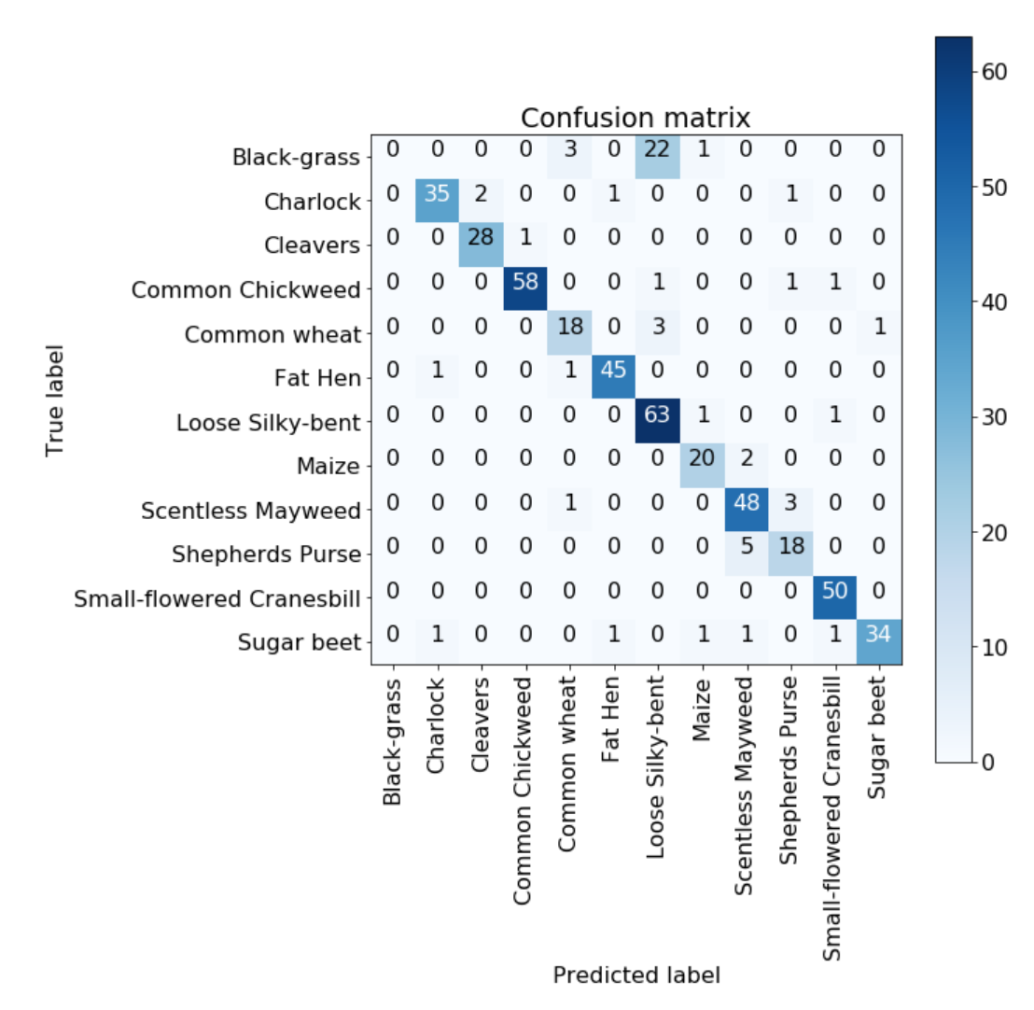

## 

## 

## 

## Conclusion

**Basic Data Augmentation**

|  |  |  |  |  |
| --- | --- | --- | --- | --- |
|  | Number of Epochs | Training Accuracy | Validation Accuracy | Test Accuracy |
| Model 1 | 3 | 90.72% | 91.79% | 94.22% |
| Model 2 | 4 | 85.40% | 88.42% | 90.22% |
| Model 3 - Original | 166 | 90.43% | 88.00% | 88.00% |
| Model 3 - Ours | 93 | 93.49% | 88.21% | 87.99% |

**Robust Data Augmentation**

|  |  |  |  |  |
| --- | --- | --- | --- | --- |
|  | Number of Epochs | Training Accuracy | Validation Accuracy | Test Accuracy |
| Model 1 | 30 | 81.02% | 82.11% | 82.10% |
| Model 2 | 30 | 13.77% | 13.68% | 13.68% |
| Model 3 - Original | 80 | 89.40% | 88.63% | 88.63% |
| Model 3 - Ours | 79 | 88.42% | 88.21% | 87.78% |

### Summary

The first was a basic model which made use of the idea that initial layers are only learning primitive features and hence filter size should increase for deeper layers because those layers are learning high level features.

Next, we tried a model that removed the max pooling layer and increased used convolution layers to reduce the parameters. Because there were too many parameters, we reduced the number of filters. The accuracy of this model was better for the basic data augmentation but for robust data augmentation, it was unable to learn the features well.

Lastly, we used a model that was a lot simpler and hence faster to run. Our modifications did not improve the model’s performance but it did allow us to reach a greater accuracy with a smaller amount of epoches. For the previous models, it took about 50 mins to get to the 3rd epoch at which point accuracy was around 90%. For the model 3 - Original, in 50 minutes, it reached the 200th epoch but maintained around 88% accuracy. The accuracy of 88% was actually reached at 43rd epoch but the model could not improve significantly from that point onwards.

In essence, our first model performed best for the standard data we were given and the third performed best for data that was more varied in terms of rotation and shifting. The varied data was harder for the second model to learn and it ended up only predicting one class this might be due to the data being unbalanced for that class and the network complexity being unsuited for this problem.

### Insights

* A model with more parameters has more representative power but this might not necessarily lead to training a more accurate model as shown by model 2.
* Filter size increase works to increase the representative power of the models and can improve accuracy more than running the network for more epochs as shown by model 1 being more accurate than model 3.
* Replacing Max Pooling with Convolution Layers did not help improve our model as shown by comparing model 1 with model 2.
* Unbalanced data could lead to a model not learning any features and instead only predicting one class.

# Future Work

From our experiments with the different models, we found that Model 1 was the most accurate for plant seedling classification.

Future development of the model could involve further fine-tuning of the hyperparameters and trying out different learning rate and optimizers.

We could also try running the layers with different filter sizes to see how the speed of training and accuracy of model could be improved.

# Workload & Contribution

|  |  |
| --- | --- |
| **Activities** | **Person in-charge** |
|
| Exploration of the Competition | All |
| Midterm Presentation | All |
| Data Set Visualization & Image Processing | Pamela |
| Experimenting - Trying different models for prediction | Pamela |
| Optimising the model - Data Augmentation Functions | Hong Wen |
| Report | Pamela |
| Poster | Hong Wen |
| Final Presentation | Hong Wen |

1. Gulshan V, Peng L, Coram M, et al. Development and Validation of a Deep Learning Algorithm for Detection of Diabetic Retinopathy in Retinal Fundus Photographs. *JAMA.* 2016;316(22):2402–2410. doi:10.1001/jama.2016.17216
2. <https://arxiv.org/abs/1609.04747>
3. Striving for Simplicity: The All Convolutional Net, [**arXiv:1412.6806v3**](https://arxiv.org/abs/1412.6806v3)
4. <https://www.kaggle.com/yassineghouzam/introduction-to-cnn-keras-0-997-top-6>